Software Requirements Specification

of

Jeev-Uthan

<<An application to help animals >>

Version 1.0

<<Annotated version>>

Date:10th March 2015

Prepared by:

Aishwarya Surana

Subhasmita Majumdar

Shraddha Bhurre

Sheetal Vishwkarma

Table of Contents

Table of contents………………………………………………………………………2

1.Introduction………………………………………………………………..3

* 1. Purpose……………………………………………………………3
  2. Document Conventions……………………………………………………….3
  3. Intended Audience and Reading Suggestions………………………………………………………..3
  4. Glossary…………………………………………………………...3
  5. Scope of project…………………………………………………...4
  6. Reference………………………………………………………….4

2.Overall Description...................................................................................... 2

2.1 Product Perspective..........................................................................2

2.2 Product Functions............................................................................2

2.3 User Classes and Characteristics.....................................................2

2.4 Operating Environment...................................................................2

2.5 Design and Implementation Constraints.........................................2

2.6 User Documentation........................................................................2

2.7 Assumptions and Dependencies..................................................... 3

3. External Interface Requirements

3.1 User Interface

3.2 Hardware Interface

3.3 Software Interface

3.4 Communication Interface

4. External Interface Requirements

4.1 Helping Hand

4.2 FAQs

4.3 Missing pets

4.4 About Us

1.Introduction

## Purpose

## The purpose of this document is to present a detailed description of the Web Application name *jeev uthan* that provide a medium between animals within various NGOs or any other needy animal and human. It will explain the purpose and features of this application, its interfaces, what the application will do, the constraints under which it must operate and how it will react to external stimuli.

## Document Conventions

<<Any comments inside double brackets such as these are *not* part of this SRS but are comments upon this SRS example to help the reader understand the point being made>>

Any text in Blue color fonts represents future enhancement of system

## Intended Audience and Reading Suggestions

This document is intended for developers, users, testers, and documentation writers. This SRS contains description of function that are provide by this web application, user classes, operating environment ,that is overall description of product, external interface requirements ,features of system, and other safety and security, requirements.

## Glossary

|  |  |
| --- | --- |
| **Term** | **Definition** |
| Author | Person submitting an article to be reviewed. In case of multiple authors, this term refers to the *principal author*, with whom all communication is made. |
| Database | Collection of all the information monitored by this system. |
| Editor | Person who receives articles, sends articles for review, and makes final judgments for publications. |
| Field | A cell within a form. |
| Reader | Anyone visiting the site to read articles. |
| Review | A written recommendation about the appropriateness of an article for publication; may include suggestions for improvement. |
| Reviewer | A person that examines an article and has the ability to recommend approval of the article for publication or to request that changes be made in the article. |
| Software Requirements Specification | A document that completely describes all of the functions of a proposed system and the constraints under which it must operate. For example, this document. |
| Stakeholder | Any person with an interest in the project who is not a developer. |
| User | Reviewer or Author. |
| FAQ | Frequently Asked Questions |

## Scope of Project

This software system will be a Web Application that will be designed to provide an interface between NGOs of animal and the person who wants to help them. It has function like FAQ that will provide first aid to injured animals. This feature of this software will facilitate user to ask his questions also.

By this product user will get the information of animal’s NGOs nearby their location and also make an interface between them. It’ll provide such platform that helps them to find their missing animals.

## References

*IEEE Software Requirements Specifications template*

# 2. Overall Description

## 2.1 System Perspective

This system is a new, self-contained product.

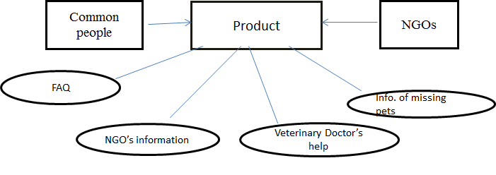

## **2.2** Project functionality

* FAQ which will provide first aid to injured animals.
* A platform where user can connect to NGOs nearby them.
* A platform where most of the people can give their missing pet’s information (with photo or any other identities).

**2.3 User Classes and Characteristics**

This product will use by people who only want to get some information about missing animals<<they are not technical expertise but have knowledge to access applications on web >>, Veterinary doctor who can help injured animals, Non-Governmental-organizations, people who wants to help animals by their services, money, food etc.

**2.4 Operating Environment**

This product will operate on any Operating System, but user should have net connection and web browser.

## 

## 2.5 Design and Implementation Constraints

* One of the limiting factors is corporate or regulatory policies in adoption of stray animals.
* Information about missing animals may be wrong; this will lead our product to less reliable.

**2.6** **User Documentation**

User can get help from “about-us” page from our web application, but in future we’ll provide online help.

## 

## 2.7 Assumptions and Dependencies

* If user won’t give the information of missing animals then our feature affects.
* Our system will depends on application called “**justdial**”, if its server is down then our system won’t be reliable.<<To remove just dial dependency we can create database of our own>>

**3.External Interface Requirements**

**3.1 User Interface**

Detailed user interface requirements have been purposefully omitted from this document. A separate user interface specification for the system's default GUI will be created.

Software components in which user interface is required are:

* Missing Pet Blog

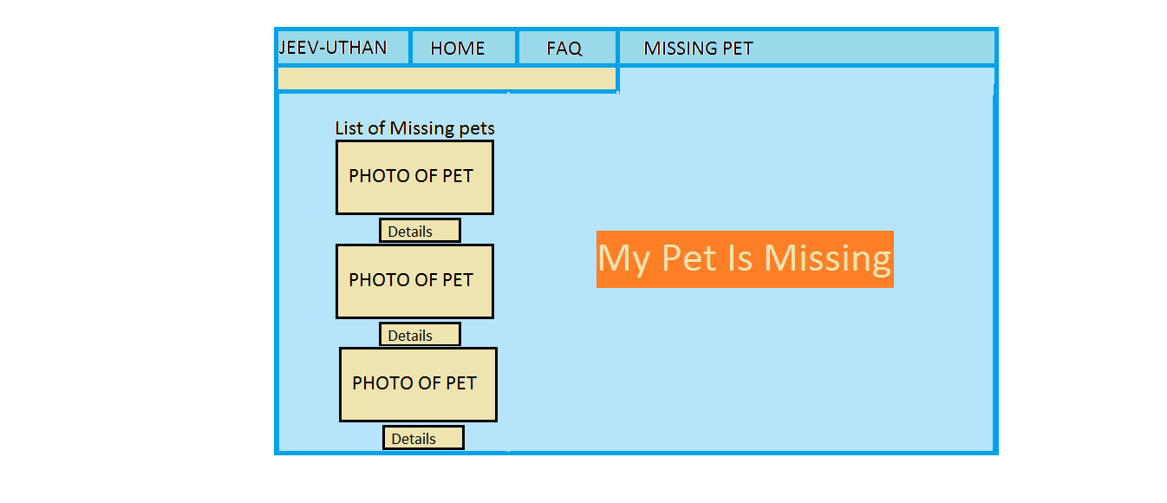

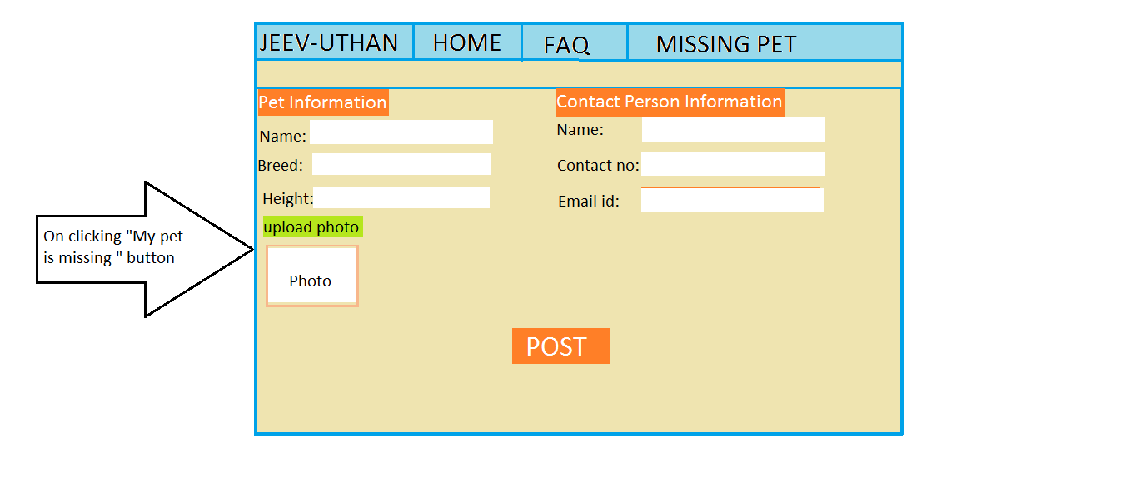

* User’s Query for nearby NGO & doctors (vets) and response in form of NGO’s Information of that area.

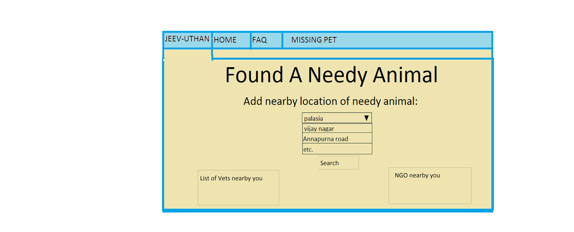

Error message will be displayed in red color and menu will appear on every page.

**3.2 Hardware Interface**

The system can be used from a computer ,mobile and tablet and it uses the hardware interface used by the WordPress using which the system is designed.

**3.3 Software Interface**

As WordPress version 4.1.1 (probability) is used to make this System which needs that host machine should contain following things:

* MYSQL database version 5.0 or greater (recommended MYSQL 5.5).
* PHP version 5.2.4or greater (recommended 5.4).
* Server must be such that it support PHP and MYSQL like Apache or Nginx or any other.

Data flow includes selection of data from database (NGO’s information) ,update (Missing pet information) , insertion (Missing pet information) and deletion (if pet is found deletion of its information from database).

**3.4 Communication Interface**

To run this system web browser is required through which all communication will happen and Internet Connection is must to access all features of the system.

**4 . SYSTEM FEATURES**

**4.1 Helping hands**

## Priority:High

## **Description:**

## As soon as someone sees any animal that is in need of help he/she can post it on the start (jeev-uthan) page.

## Give his nearby location.<<Combo boxes will be provided>>

## System response:

## From his nearby location , nearby ngos contact information would be provided by the system.<<This is done via just dial’s database(if possible else creating database of our own)>>

**Functional Requirement:**

* Input
  + Selecting nearby location from combo box
* Output
  + Contact information of nearby NGO or Veterinary doctor.

**4.2 FAQs**

## Priority:

## Medium

**Description:**

## Through this static information with the help of web page can be given to the user about how to provide first aid to any animal in need.

* Further advancement can be done by letting the user to post his/her question

**System Response:**

* **Display page with content**

## Questions saved in database would provide answers to the user.

**Functional Requirement:**

* **Input**
  + No input from the user required
* **Output**
  + Information would be displayed.<<Since it would be static page>>

## 

## 

## 

## 

## 

## 4.3 Missing Pets

**Priority:**

High

**Description:**

## People can give information about their missing pets providing:

* + Name
  + Color
  + Breed
  + Height
* And if the pet is found than to contact the person whose pet was missing they will provide their information that are:
  + Name*
  + Contact number*
  + Address
  + Email

**System Response:**

* Information about pet would be saved in the database.
* Whenever anyone looks to this Missing pets page he/she would see information about the pets <<just like posts on fb>>.
* If pet is found than user would click on found button and then he would be provided by the contact information of the owner.
* When pet is found information would be deleted.

**Functional Requirement:**

* **Input**
  + Entry of information about missing pet by its owner.
  + Information about owner of pet.
* **Output**
  + Display of posts about missing pets.

**4.4 About application**

**Priority:**

Medium

**Description:**

A static page in which user will know about:

* Features of the application.
* How to use this web application.

**System Response:**

* As user clicks on the page this information would be displayed.

**Functional Requirement:**

* **Input**
  + No input from the user required
* **Output**
  + Information would be displayed.<<Since it would be static page>>

**4.5 Suggestions**

**Priority:** Low

If user have any suggestion regarding the website he can write in this suggestion dialog which would be saved in database and can be referred by the developers.

**4.6 Login**

**4.6.1 Description and Priority**

**Priority**:

High

**Description:**

* People can give information only after they login.
* They can tell about their missing pets.
* By this we can know who wants to adopt any stray animals.

**4.6.2 Stimulus/Response Sequences**

As user login system would ask:

* + - Email
    - Contact information
    - City he lives in

<<City could be traced with the help of contact info>>

**4.6.3 Functional Requirements**

REQ-1: Validate Email

REQ-2: Validate contact information

REQ-3: If doctor than must be given highest priority also ensuring that its not fake.

## 4.6.4 Blogs

**Priority**:

Low

**Description:**

* Any person who is having any information about how to help any “JEEV” can write it on there blogs.
* Whenever first aid or any sort of help is requires by any animal than that particular person can ask question refer either to that blog.

<<No login required for any querry>>

**5.Other Nonfunctional Requirements**

## 5.1 Performance Requirements

The various software requirements for the product under various circumstances accounts for good performance and to help developers make suitable design choices. This involves database requirement and easy data retrieval.

Considering the real time system factor, the timing relationship includes a specific timing within which the user or NGO, signing in, would be able to retrieve data from the database with acclaimed information.

## 5.2 Safety Requirements

<Specify those requirements that are concerned with possible loss, damage, or harm that could result from the use of the product. Define any safeguards or actions that must be taken, as well as actions that must be prevented. Refer to any external policies or regulations that state safety issues that affect the product’s design or use. Define any safety certifications that must be satisfied.>

## 5.3 Security Requirements

The requirements regarding security or privacy issues surrounding use of the product or protection of the data used or created by the product necessitates user identity authentication.

Database security deals with all various aspects of protecting the database content, its owners, and its users. It ranges from protection from intentional unauthorized database uses to unintentional database accesses by unauthorized entities (e.g., a person or a computer program).

## 5.4 Software Quality Attributes

The product ensures reliable user interface that is easily adaptable by the users of that product. It also incorporates well grounded interoperability of different DBMS (A database is not generallyportable across different DBMSs, but different DBMS can interoperate by usingstandards such asSQL andODBC orJDBC to allow a single application to work with more than one DBMS).

## 5.5 Business Rules

This mentions various operating principles of the product. The various circumstances under which our product would be used is, firstly by users who indeed want to help animals. Secondly, it will connect the user to the various NGOs (with the motto of helping animals). For this the system provides a platform for various NGOs can register themselves as authentic users.

# 6. Other Requirements

<<Define any other requirements not covered elsewhere in the SRS. This might include database requirements, internationalization requirements, legal requirements, reuse objectives for the project, and so on. Add any new sections that are pertinent to the project.>>